AI LAB Task 04
Problem, Assumptions Implementation
Problem;
Campus navigation system find low-cost route from start building S to destination G the actual travel time already spent
g(n) and estimate time still needed h(n) A* orders it frontier by
f(n) = g(n) + h(n)
So it reach G while expand fewer irrelevant building than uninformed search supplied instance five buildings as well as five directed edges Two complete routes exist:
S to A to C to G
Cost,
1 + 2 + 3 = 6
S to B to G costs 4 + 5 = 9

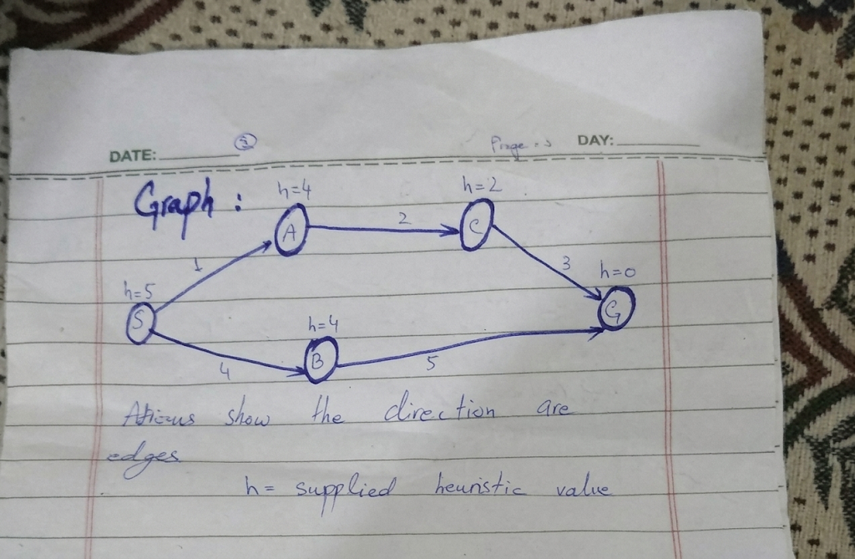
Assumptions;
Edges directed as well as weights no negative travel
h values abstract time estimate supplied the manual; no measured distances raw straight line distance meters not added a travel time so h must be in same time units as edges
Single start S as well as single goal G Results describe one small instance only.
Counting convention; a node is expanded only when its successors examined process goal logged as well as no counted stale queue entries ignore as well as reported separate
Tie break; key is (f, g, node, path) smaller f first so smaller g then alphabetical node name Successors follow a adjacency list order so tie bet frontier entries actually occur any run report

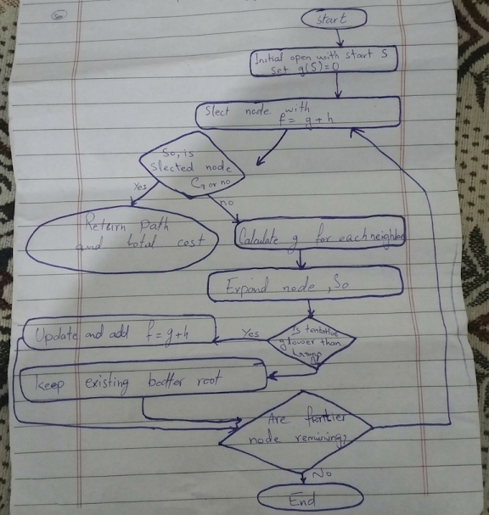

Implementation choices;
Priority Queue; Python heap holds (f, g, node, path) tuples so next node process always one with smallest f path store in entry so route can return without back pointers
Best Cost Table; best no. stores cheapest g found so far successor pushed only if g + w < best no. which is the ‘update better paths’ rule from trigger questions
Lazy Deletion Stale Entries; heapq not cheaply remove old entry so a entry popped with g != best node it skip this instance not stale entry ever occurs (stale = 0 in all runs).
UCS Control = The Same Function h = 0 for every node so only thing changes bet. A* as well as UCS runs is heuristic controlled comparison
Instrumented Version record every pop every successor calculation as well as frontier after each step validates inputs the supplied function from manual kept no change the code as well as use cross check instrumented one

Cost, Every push or a pop costs O (log n) with consistent heuristic each node expanded most once so the pushes bounded by number of edges; with admissible but not consistent heuristic node can Re-expanded when cheaper route found which this implementation allows.

Task 1-
Manual g, h, f calculations;
Start S, goal G, supplies heuristic f = g + h every row frontier column lists every entry remains after expansion as well as last column explain next selection

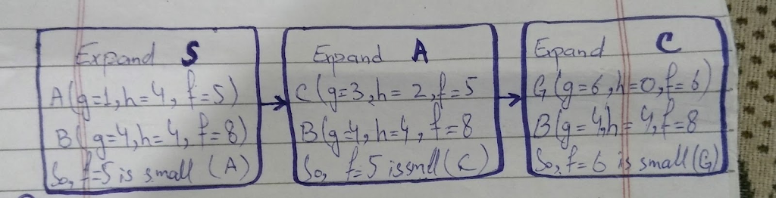

First three A* Exp.
1-
Selected Node:
S, g = 0, h = 5, f = 0 + 5 = 5
Successors Generated; A: g = 0 + 1 = 1, f = 1 + 4 = 5
B: g = 0 + 4 = 4, f = 4 + 4 = 8
Remaining Frontier;
A: g=1, h=4, f=5
B: g=4, h=4, f=8
The next node: A is selected; f = 5 is the small
2-
Selected Node;
A, g = 1, h = 4, f = 1 + 4 = 5
Successors Generated;
C: g = 1 + 2 = 3, f = 3 + 2 = 5
Remaining Frontier;
C; g=3, h=2, f=5
B; g=4, h=4, f=8
The next node is C is selected; it f = 5 is the small
3-
Selected Node;
C, g = 3, h = 2, f = 3 + 2 = 5
Successors Generated;
G; g = 3 + 3 = 6, f = 6 + 0 = 6
Remaining Frontier;
G; g=6, h=0, f=6
B; g=4, h=4, f=8
The next node is G is select it f = 6 is the smallest
After third G (f = 6) is front of frontier as well as B (f = 8) behind it G goal So A star stops as well as returns S to A to C to G a cost 6 the f-values of nodes expanded way 5, 5, 5. So then 6 at goal f never decreases path what a consistent heuristic guarantee
Heuristic Audit;
True remain costs h*(n) obtain listing each node G independent of A star
S; 6, A; 2 + 3 = 5, B; 5, C; 3, G; 0
3-
Heuristic Audit
True remaining costs h*(n)
Obtain list every route each node G (independently of A*)
S; 6, A; 2 + 3 = 5, B; 5, C; 3, G; 0.
Admissibility Check
Node S h(n); 5; True h*(n): 6; Check h ≤ h*: 5 ≤ 6
Result: PASS
Node A h(n); 4; True h*(n): 5; Check h ≤ h*: 4 ≤ 5
Result: PASS
Node B h(n); 4; True h*(n): 5; Check h ≤ h*: 4 ≤ 5
Result: PASS
Node C h(n); 2; True h*(n): 3; Check h ≤ h*: 2 ≤ 3
Result: PASS
Node G h(n); 0; True h*(n): 0; Check h ≤ h*: 0 ≤ 0
Result: PASS

Consistency Check Every Directed Edge
Edge S to A
cost(u,v): 1; h(u): 5; cost + h(v): 1 + h(A) = 5; Check h(u) ≤ cost + h(v): 5 ≤ 5;
Result: PASS
Edge S to B
cost(u,v): 4; h(u): 5; cost + h(v): 4 + h(B) = 8; Check h(u) ≤ cost + h(v): 5 ≤ 8;
Result: PASS
Edge A to C
cost(u,v): 2; h(u): 4; cost + h(v): 2 + h(C) = 4; Check h(u) ≤ cost + h(v): 4 ≤ 4;
Result: PASS
Edge B to G
cost(u,v): 5; h(u): 4; cost + h(v): 5 + h(G) = 5; Check h(u) ≤ cost + h(v): 4 ≤ 5;
Result: PASS
Edge C to G
cost(u,v): 3; h(u): 2; cost + h(v): 3 + h(G) = 3; Check h(u) ≤ cost + h(v): 2 ≤ 3;
Result: PASS

Verdict; Supplied heuristic admissible consistent on all five edges the A to C edge tight (4 ≤ 4) as well as So S to A (5 ≤ 5) so no slack on optimal route these checks were done calculate no assume.

Task 2
A* versus UCS Same Graph
Same weighted graph same endpoints, same code, same tie-break as well as same counting rule only heuristic differs so the UCS control uses h = 0 for every node so it f equals g.
A* trace with Supplied heuristic;
Step 1;
Popped (g, h, f): S, g = 0, h = 5
f = 0 + 5 = 5
Expand S;
A; g = 0 + 1 = 1
f = 1 + 4 = 5 Pushed
B; g = 0 + 4 = 4
f = 4 + 4 = 8 Pushed
Frontier afterwards:
A; g=1, h=4, f=5
B; g=4, h=4, f=8
Step 2
Popped (g, h, f): A, g = 1, h = 4
f = 1 + 4 = 5
Action:
Expand A:
C; g = 1 + 2 = 3,
f = 3 + 2 = 5 Pushed
Frontier Afterwards;
C; g=3, h=2, f=5
B; g=4, h=4, f=8
Step 3
Popped (g, h, f): C, g = 3, h = 2
f = 3 + 2 = 5
Action:
Expand C:
G; g = 3 + 3 = 6, f = 6 + 0 = 6 → pushed
Frontier Afterwards:
G; g=6, h=0, f=6
B; g=4, h=4, f=8
Step 4
Popped (g, h, f): G, g = 6, h = 0
f = 6 + 0 = 6
Action: Goal reached: stop, return cost 6
Frontier Afterwards; B: g=4, h=4, f=8

UCS Control Trace (h = 0)
Step 1
Popped (g, h, f): S, g = 0, h = 0
f = 0 + 0 = 0
Action:
Expand S:
A; g = 0 + 1 = 1, f = 1 + 0 = 1 Pushed
B; g = 0 + 4 = 4, f = 4 + 0 = 4 Pushed
Frontier Afterwards:
A: g=1, h=0, f=1
B: g=4, h=0, f=4
Step 2
Popped (g, h, f): A, g = 1, h = 0, f = 1 + 0 = 1
Action:
Expand A:
C: g = 1 + 2 = 3,
f = 3 + 0 = 3 Pushed
Frontier Afterwards:
C: g=3, h=0, f=3
B: g=4, h=0, f=4
Step 3
Popped (g, h, f): C, g = 3, h = 0
f = 3 + 0 = 3
Action:
Expand C:
G; g = 3 + 3 = 6
f = 6 + 0 = 6 Pushed
Frontier Afterwards:
B; g=4, h=0, f=4
G; g=6, h=0, f=6
Step 4
Popped (g, h, f): B, g = 4, h = 0
f = 4 + 0 = 4
Action;
Expand B;
G; g = 4 + 5 = 9
f = 9 + 0 = 9 Rejected (best g is 6)
Frontier Afterwards; G: g=6, h=0, f=6
Step 5;
Popped (g, h, f): G, g = 6, h = 0,
f = 6 + 0 = 6
Action: Goal reached: stop, return cost 6
Frontier Afterwards; Empty

A* Versus UCS
A*, supplied h
Returned Path; S to A to C to G
Reported cost: 6; Independently summed cost: 1 + 2 + 3 = 6; Expanded nodes; S, A, C; Count: 3; Stale: 0
UCS, h = 0
Returned Path S to A to C to G
Reported cost: 6; Independently summed cost: 1 + 2 + 3 = 6; Expanded nodes; S, A, C, B; Count: 4; Stale: 0
Interpretation, Both Algorithms return same optimal path cost 6 expect, because heuristic is admissible the diff. effort; A* expand 3 nodes (S, A, C) as well as UCS expand 4 (S, A, C, B). UCS orders frontier by g alone, So B (g = 4) is process before G (g = 6). A* orders f, B
So, f = 4 + 4 = 8 which behind G with f = 6, so B is no expand B only leads to G at cost 9, So expand it waste work.

Task 3;
Overestimating One Heuristic Value
Only h(C) changed from 2 to 10 every input, including h(G) = 0 is no change the true remaining cost C is h*(C) = 3 so modified value overestimate 7 as well as deliberately breaks admissibility
A* Trace h(C) = 10
Step 1
Popped (g, h, f); S, g = 0, h = 5, f = 0 + 5 = 5
Expand S;
A; g = 0 + 1 = 1, f = 1 + 4 = 5 Pushed
B; g = 0 + 4 = 4, f = 4 + 4 = 8 Pushed
Frontier Afterwards;
A; g=1, h=4, f=5
B; g=4, h=4, f=8
Step 2
Popped (g, h, f); A, g = 1, h = 4, f = 1 + 4 = 5
Expand A;
C; g = 1 + 2 = 3, f = 3 + 10 = 13 Pushed
Frontier Afterwards;
B; g=4, h=4, f=8
C; g=3, h=10, f=13
Step 3
Popped (g, h, f);; B, g = 4, h = 4, f = 4 + 4 = 8
Expand B:
G: g = 4 + 5 = 9, f = 9 + 0 = 9 Pushed
Frontier Afterwards;
G; g=9, h=0, f=9
C; g=3, h=10, f=13
Step 4
Popped (g, h, f); G, g = 9, h = 0, f = 9 + 0 = 9
Action: Goal Reached; stop, return cost 9
Frontier Afterwards; C: g=3, h=10, f=13

Effect of Single-Value Overestimate

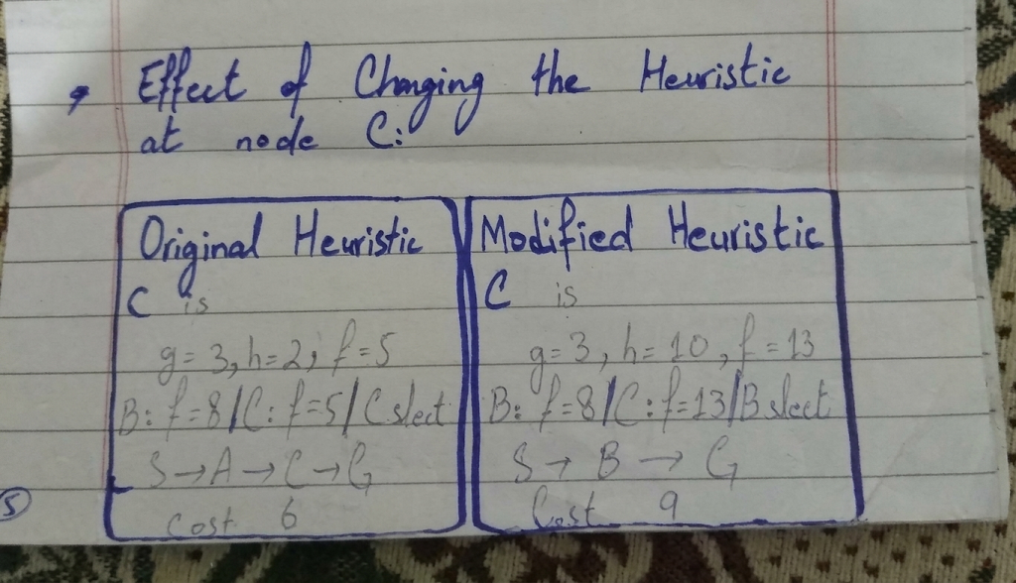

h(C)
Original heuristic; 2; Modified heuristic: 10
True Remaining Cost of C;
Original heuristic; 3; Modified heuristic: 3
f(C) when C is generated;
Original heuristic; 3 + 2 = 5; Modified heuristic: 3 + 10 = 13
Admissible;
Original heuristic; yes / yes; Modified heuristic: no / no (C → G: 10 > 3 + 0)
Returned path;
Original heuristic:; S to A to C to G; Modified heuristic: S to B to G
Returned cost (independent sum);
Original heuristic; 6 (6); Modified heuristic: 9 (9)
Expanded nodes (count);
Original heuristic; S, A, C (3); Modified heuristic: S, A, B (3)
Optimal? (9 > 6)
Original heuristic: yes
Modified heuristic: no

6-
Limitation
Only one very small Graph abstract heuristic values use the 3-versus-4 expansion result no measure campus travel as well as no predict saving larger maps
Efficiency measure only expansion count Run-time, memory as well as queue pushes no measure as well as on graph this small time dominated by noise
Admissibility confirms listing routes, that work five nodes, larger graphs need reverse short-path computation obtain h* or analytical argument
One tie breaking rule use on graphs equal f-values another rule could can change count although no tie occurs runs report
Real campus rout would need measure travel times a unit conversion for distance-based estimate

7-
Failure and edge-case analysis
3 edge cases run against supplied function manual as well as against the instrumented version.
Edge-case summary
Case 1;
Start equals goal (S to S)
Input; start = goal = S
Observed behaviour; Returns cost 0, path [S], zero expansions.
Likely cause; Correct.
The goal test runs before any expansion.
Proposed improvement; None needed.
Case 2;
Goal unreachable
Input; Extra isolate building D (h(D) = 0), goal D
Observed behaviour; Supplied function returns None, cost, path = astar(...) raises TypeError: cannot unpack non-iterable NoneType object.
Likely cause;
The loop ends when the frontier is empty and the function has no return statement for failure, so Python returns None.
Proposed improvement; Return an explicit failure value or raise a clear exception; the instrumented version reports found = False.
Case 3;
Missing heuristic entry
Input: h(C) deleted from the table
Observed behaviour; Supplied function raises KeyError 'C' part-way through a run so only when C is first generated.
Likely cause; The heuristic table is read lazily with h[nxt]; miss node detected late, as well as never if node unreachable.
Proposed improvement; Validate the table before searching; the validated version raises ValueError: heuristic value missing for node(s): ['C'].

Detailed failure Unreachable Goal
Input: the campus graph plus an isolated building D with no incoming edge, start S, goal D. Observed;
A* explores every reachable building (S, A, C, G, B; 5 expansions) as well as then stops with empty frontier but supplie function silently returns None caller that unpacks the result crashes with a TypeError that says not about the real problem (no route exists) Likely cause; Function defines what return success only Proposed improvement; make failure part of function's contract as well as example return (inf, None) or raise NoRouteError as well as have the caller test for it the instrumented version returns found = False expansion count which how experiment record this case
The overestimate experiment Section 5 is a fourth logical failure so program runs without any error but returns non-optimal route Its cause is invalid input rather than code error as well as improvement to audit every heuristic value (Section 3) before relying A* optimality
8-
Viva Explan Design Choices
Why a priority queue?
A* always take frontier entry with smallest f heap gives that O(log n) per push pop instead scan whole frontier
What do g, h and f mean?
g(n) is real cost from S to n so far, h(n) is estimated cost from n to G, and f(n) = g(n) + h(n) estimated total cost of route through n
What does the check g! = best[node] do?
Skips stale entries node can pushed again when cheaper route is found so the older costlier copy stays heap as well as ignored when is popped here none occurred
What happens when h(n) = 0 for every node?
f equals g, so A* behave like uniform-cost search is still optimal so explores more 4 expansions instead of 3 this graph.
Admissible versus consistent?
Admissible:
h(n) ≤ h*(n)
Consistent:
h(u) ≤ cost(u,v) + h(v)
Consistency with h(G) = 0 implies admissibility as well as makes f non-decreasing along path as seen 5, 5, 5, 6 an admissible heuristic need not consistent.
Why does an overestimate threaten optimality?
Inflate f above true cost of best solution so optimal route sinks behind worse one with h(C) = 10, f(C) = 13 lost G at f = 9 as well as cost-9 route was return
Why count expansions rather than compare path length?
Both algorithms return same path so path length shows no diff. saving only appears in trace.
How were ties broken, and did it matter?
By smaller f then smaller g then node name No tie occurs runs so the results no depend it
Why are the h values not measured metres?
Manual gives abstract time estimates distance as well as time diff. units so metre value would need conversion before use
9-
Reflection
What did I learn today?
A* combines what already been spent with estimate of what remains as well as quality of that estimate decide both speed as well as correctness the supplied heuristic A* need one expansion fewer UCS as well as still return optimal cost
How will I apply this in a real AI system?
In route or plan I would audit heuristic before using it keep units consistent with edge costs as well as log expansion counts as well as path costs together so efficiency claim always backed by trace.
What failed or surprised me?
Overestimate kept expansion count at 3 while returned cost rose from 6 to 9 as well as second overestimate h(B) = 10 change no run is no proof of safety
What would I do differently next time?
Test more than 1 graph as well as larger 1 record queue pushes as well as run time as well as expansions so write failure cases before main experiment

